|  |  |
| --- | --- |
| Name | Radwa Mohamed Ali Ebrahiem Elsayed Elmahdy |
| School | WE Elmansoura |
| Date | 28/11/2024 |
| Task | 2 |

Introduction:-

A security system is a combination of devices, technologies, and strategies put in place with the focus of protecting individuals, property, and information from possible threats of theft, burglary, cyberattack, and vandalism. Its ultimate purpose is to provide security and privacy by monitoring the environment uninterruptedly to notice any probable danger or unauthorized activity that may take place , The security systems may be very simple or very complex. The simplest ones could involve locks or some low-budget cameras, while others can be more complex, featuring motion detectors, automated alarms, video surveillance, and the possibility of monitoring from a distance using the internet. Additionally, firewalls and antivirus provide protection against digital breaches and malware infections. , From large corporations that employ sophisticated, integrated systems to the homeowner with a simpler setup, security systems are designed to meet specific needs and help someone feel safe and in control.

* Requirement Type

1. Business Owner’s Requirement:

* Easy access to company information (services offered, contact

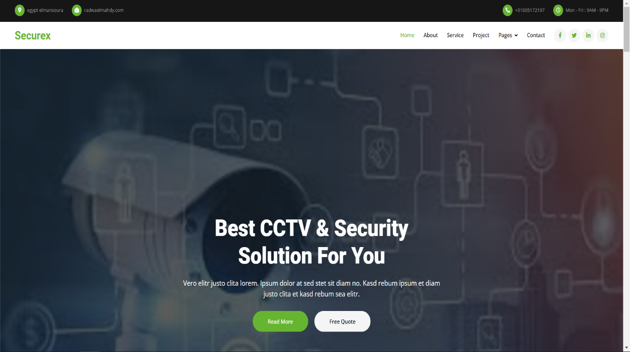Details)

* 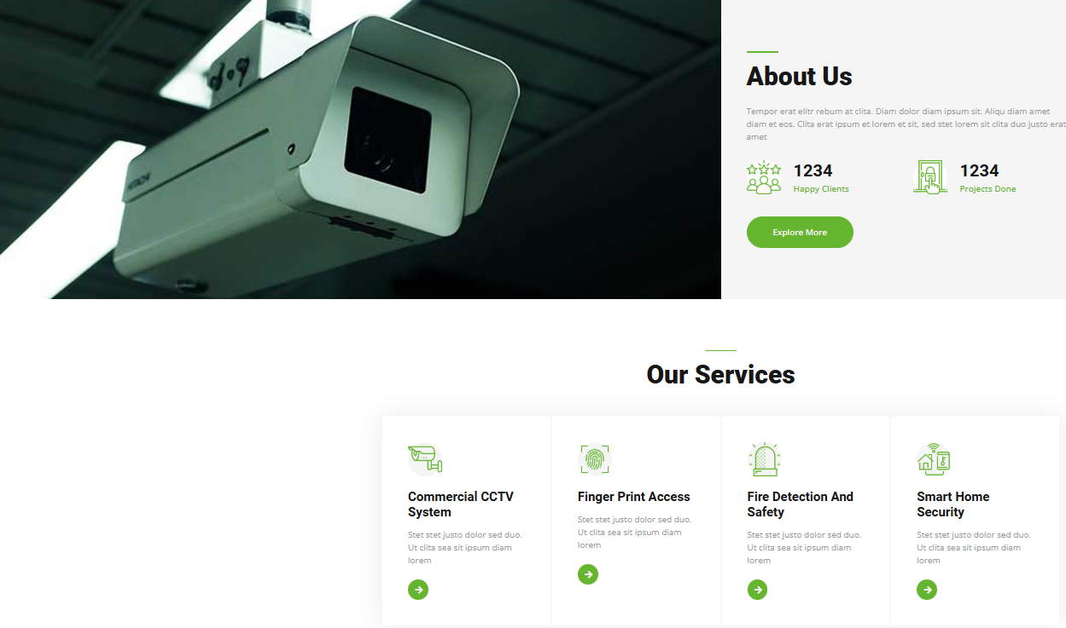Ability to showcase security system products and installations
* Provide a platform for customer inquiries and service bookings
* Integration of customer testimonials and case studies
* it is the Mobile-friendly and responsive design for both home and business Users.]
* SEO-optimized pages to improve visibility and beautiful color good to eyes

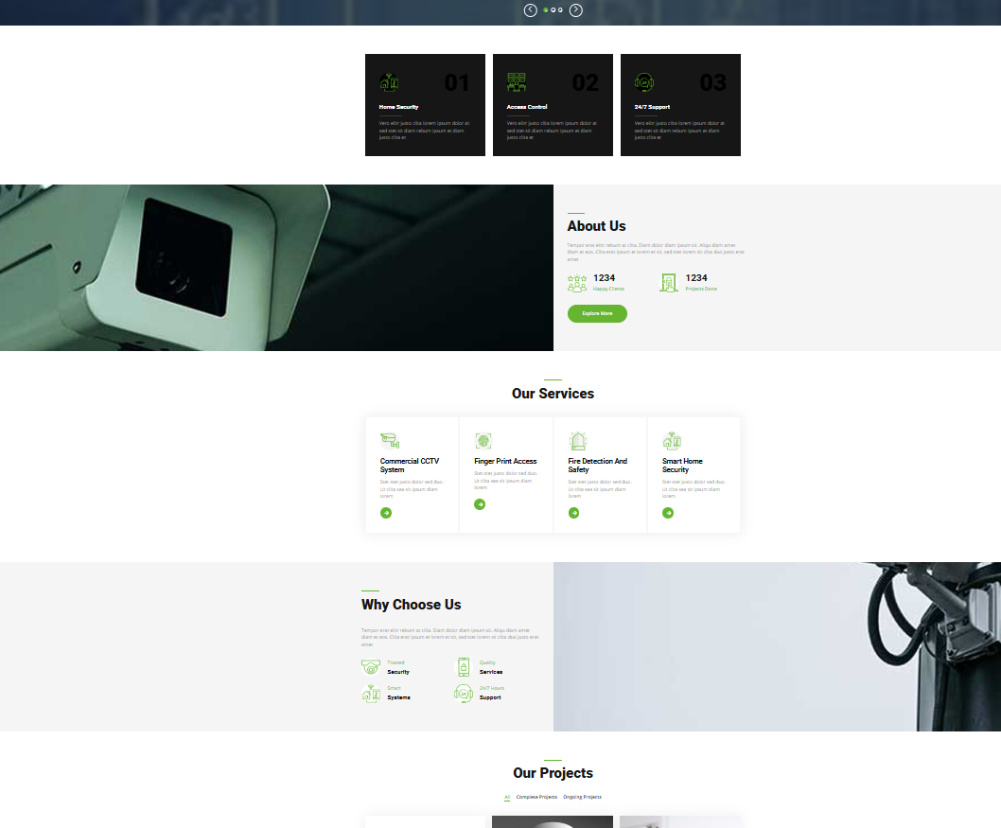

1. End Users’ Requirements:

• Clearly visible menus, intuitively grouped:

Navigation and intuitive layout are the two basic principles of website, app, or any digital platform development. Here's what they typically involve:

1. Clear Navigation:

Simple Menu Structure: Menus should not be hard to find and must be easily understandable. Use clear categories and avoid overwhelming users with too many options.

Logically Flowing Navigation: Ensure the navigation flow makes sense and groups related items together, providing easy ways for users to move between sections.

Prominent Call-to-Action Buttons: Buttons for primary actions ("Sign Up," "Learn More," or "Shop Now") will be easily visible and intuitively take users to their next steps.

Search Functionality: Provide a search bar if necessary that's prominently placed and easily accessible.

- Breadcrumbs: In the case of more complicated websites or applications, breadcrumbs show the path taken by the user and help the latter know his current position in the site, allowing him to get back to previous parts of the site quickly and easily.

- Responsive and Consistent: Navigation should work well across all devices, automatically adapting to different screen sizes. Consistent placement of navigation elements enhances usability.

2. Intuitive Layout

• Clean Design: Ensure that the layout is clean, not cluttered. White space is important for readability and makes the interface pleasant and easy to use.

• Visual Hierarchy: Use size, color, and placement to guide users to the most important elements first. For example, key sections or buttons need to be the most prominent.

Consistent design patterns include using design patterns and UI elements with which people are generally familiar. People get used to certain patterns-a hamburger menu on mobile, or a top bar on desktop-that they know instinctively.

Focus on User Goals: Design the layout around the actions the users want to perform. If it's an e-commerce website, the layout should facilitate product browsing and checking out.

- Feedback and Guidance: Immediate feedback on interaction with the interface, such as button presses, loading animations, etc., should be provided, while guidance should be given when necessary-tooltips, tutorials, etc.

- Fast Load Times: An intuitive layout is not only about visual structure but also the performance of the platform. A fast and responsive layout enhances overall user experience.

Best Practices:

Navigation Menu: Simple with the key options: "Home," "Products," "About," "Contact," and maybe "Search."

Typography: Clearly legible font; headings are to differ from the text of the paragraphs. Hierarchy in text (using different font sizes) helps users easily scan content.

Mobile Optimization: The layout has to look nice on small screens with clear, touch-friendly buttons and easily readable content.

By adhering to these principles, you can create a seamless and efficient experience for users.

• Product information easily accessible, installation services

• Quickly loading, mobile-friendly

• Safe to browse, contact forms present

• Ability to browse services by category - e.g., Home Security, Small

Business Security

• Ability to request a quote or book an installation service online

* Alternative

The particle nav in it is clear and comfortable for the eye, and if he replaces a nav with bi and shares it, it is clear for the eye.

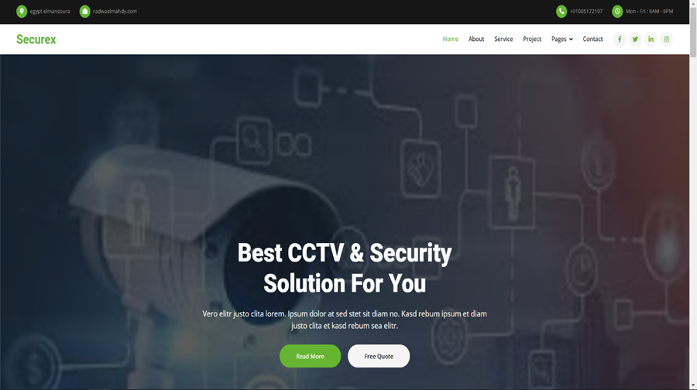

* Reviews

We value your opinions for our growth and betterment; if you have been given the chance to use our site or services, we would love to hear from you. We always want to do things better, and it's because of your insight that will drive us forward. Love something, or can we do better-your review counts.

Feedback

More natural-sounding customer reviews to include are listed below

Customer Reviews:

1. "Amazing Service and Easy to Use!""Smooth experience while using the site. All items are accessible in due time, and the design is super friendly. Had one question, and customer service was quick to help. Definitely recommend this site to my friends!"

2. "Best [service/product] Site Out There!

"I have tried many sites for [your service/product], but this one beats the rest. Quick, efficient, and the quality is outstanding. I'll keep coming back for more, and I've already spread the word to family and friends.

3. Easy and Trustworthiness:

"I was looking for [specific service/product], and this site made it so easy. The navigation is simple, and I found exactly what I needed in no time. I'll definitely use it again in the future."

4. "Great Experience From Start to Finish"

"From the moment I visited the site, I felt at ease. Everything is so well-organized, and when I had a question, the customer service team was quick to respond. I'm very impressed and will happily recommend this site to others."

5."High Quality and Great Attention to Detail"

What stood out for me was the attention to detail, the quality of the service. I had a question, and the support team handled it quickly and professionally. I feel confident using this site.

6. "Excellent Value for Money"

"I love how much value you get here for the price. The quality of the service is top-notch, and it's way better than other similar sites I've tried. I'm very satisfied with my experience."

Conclusion:

In essence, security systems are in place to safeguard all that is dear, be it your home, business venture, or personal information. As the nature of threats has escalated-from burglars and break-ins to cyberattacks-the need to have appropriate security has also increased. New-generation security systems have moved way ahead, offering remote monitoring, instant alerts, integrated protection for physical and digital assets, and a lot more.

A good security system makes you confident that you try to protect yourself, your property, and your information. The key is finding the right combination of tools-like cameras, alarms, and access control-that fits your particular needs. With technology continuously improving day by day, one must try to stay updated about the latest security solutions in order to keep themselves protected.

The point of any security system, in the end, boils down to one simple thing: to keep you safe and secure enough to go about your day without having to worry about the potential risks.